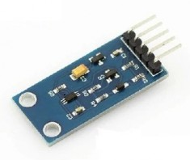
This project can test Digit light sensor module. When light is detected by sensor, the Arduino serial monitor will show light density level.
Step 1: Connect sensor to Arduino as per following graph:
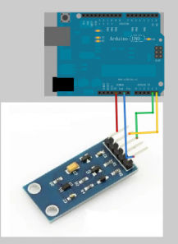
Step 2:Download Sample Code and load it into Arduino.
Step 3:Run the code, open the Arduno serial monitor window in the upper right corner, you will see following result in the video:

